**Week 1 Task - Cloud (AWS) Submission**

**Introduction**

This report details the step-by-step process followed to complete the AWS-based task assigned as part of the Techplement Internship. The document includes explanations, references used, and screenshots of the AWS services configured.

**Steps Followed for monolithic**

**Step 1: Setting Up the Environment**

* Created an AWS account and configured IAM roles.
* Launched an EC2 instance (Ubuntu) and set up the security groups.

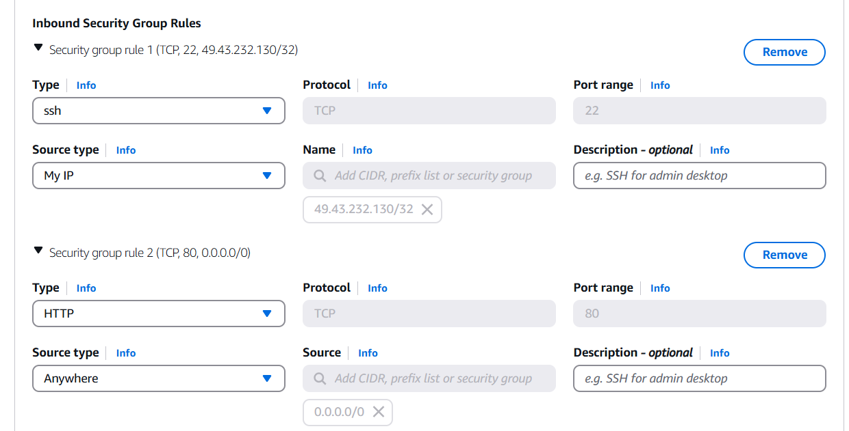

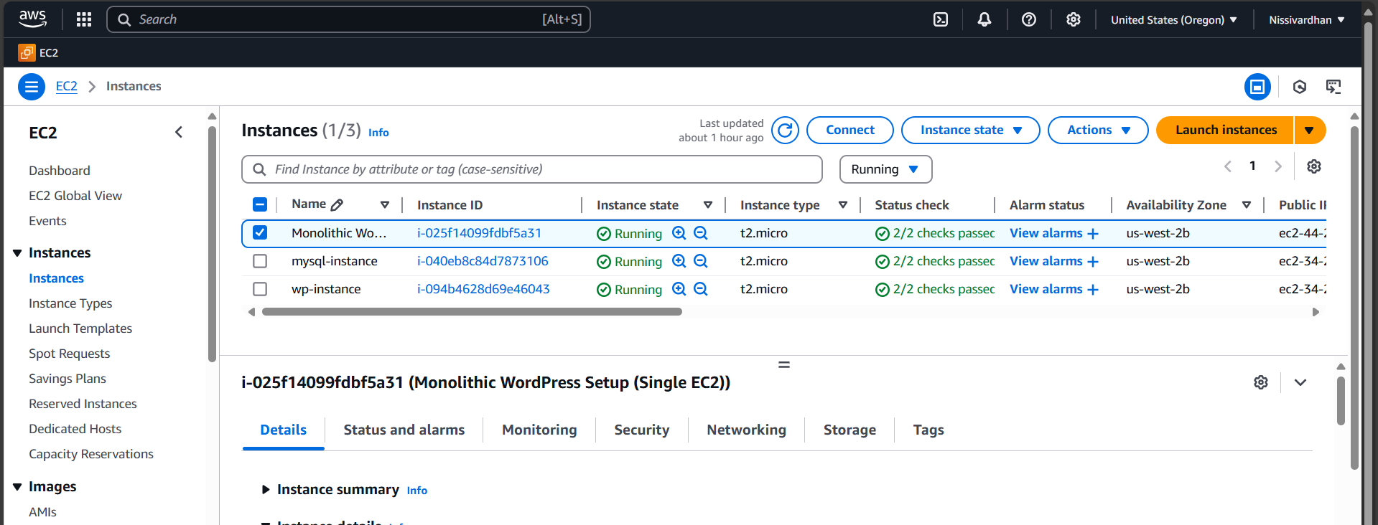

* Connected to the instance via SSH.

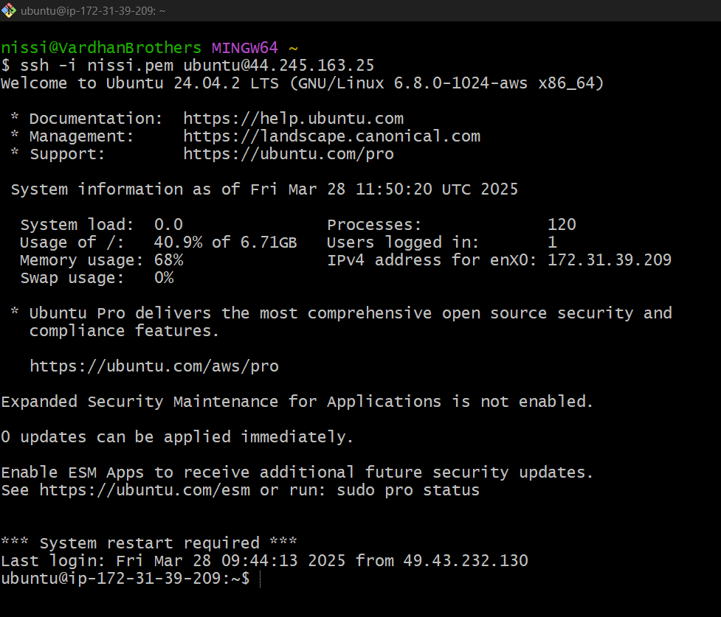

**Installing Required Packages**

* Installed Apache2 web server and MySQL database.
* Configured necessary firewall rules.

**Configuring MySQL Server**

* Created a MySQL database for WordPress.
* Created a user and granted privileges.

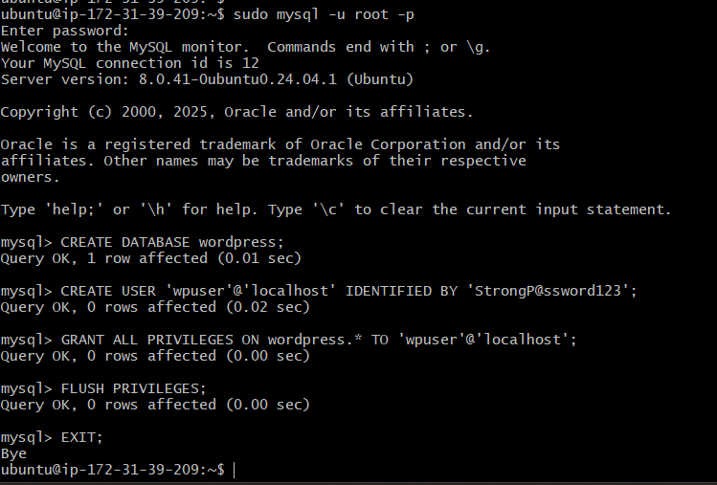  
  
 **Deploying WordPress**

* Downloaded and extracted WordPress.
* Configured the wp-config.php file to connect to the database.

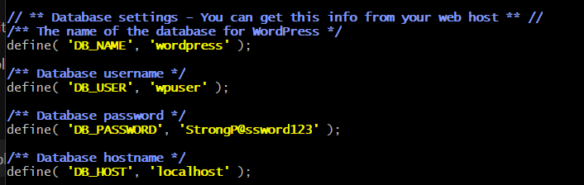  
  
History of commands used on Single Instance

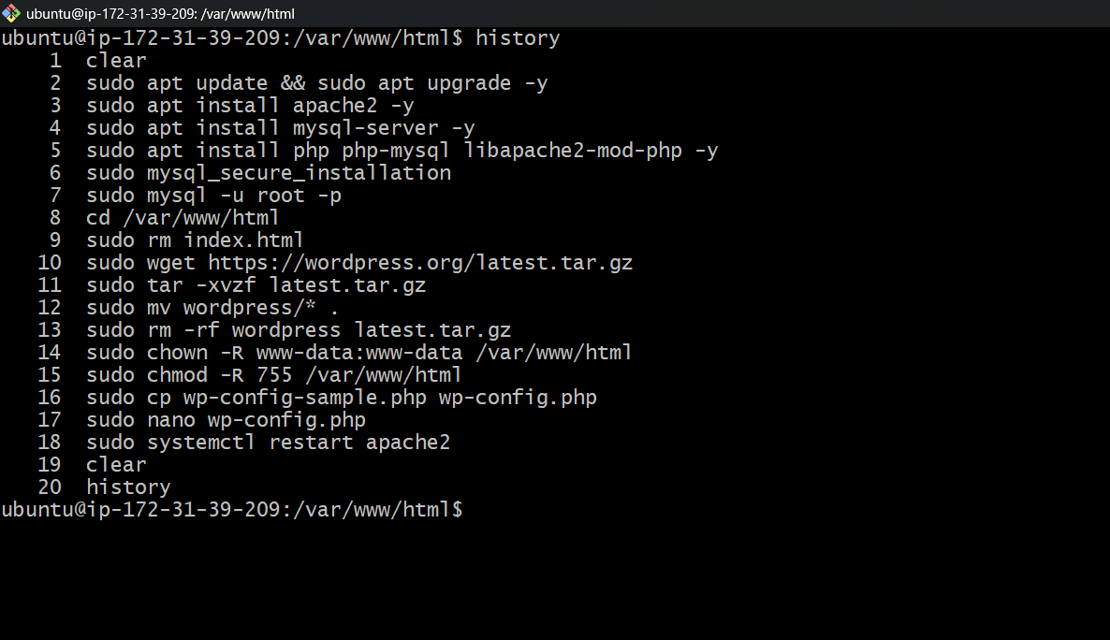

Accessed the WordPress site through the public IP.

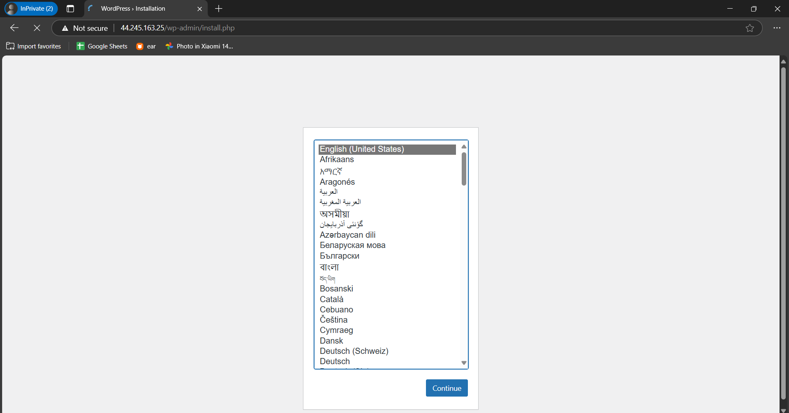

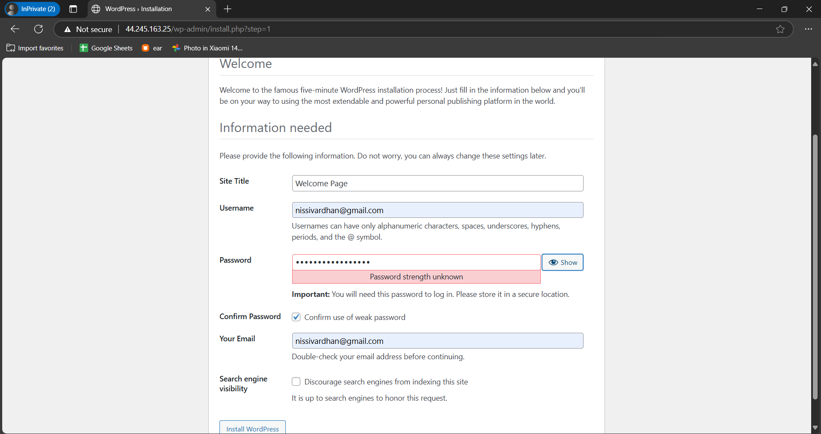

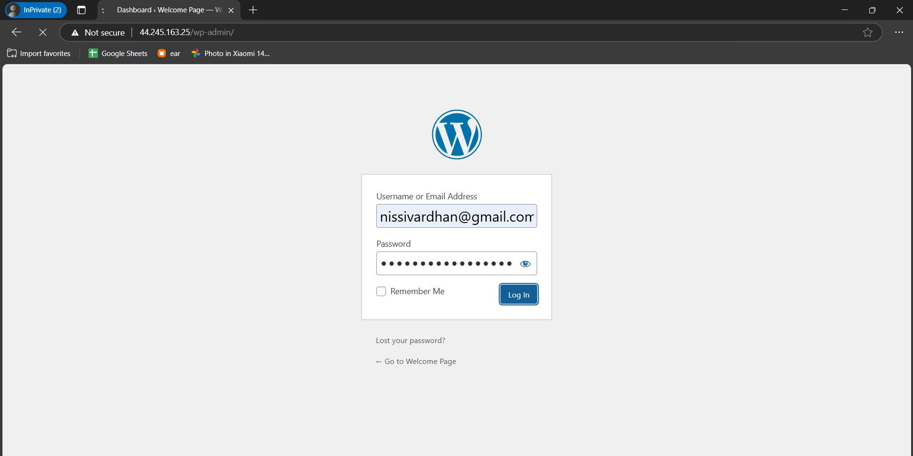

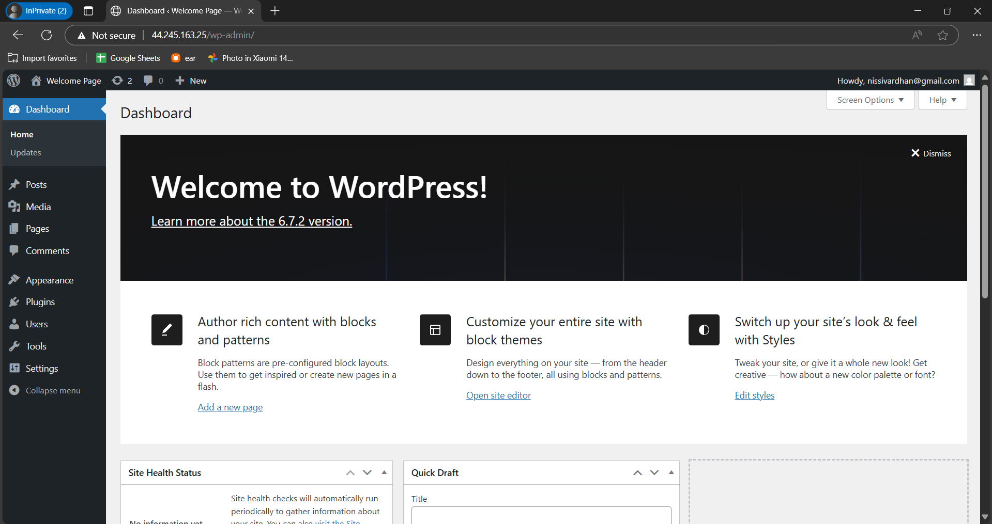

**Introduction**

This report details the step-by-step process followed to deploy a **WordPress application** using a **microservices** **architecture** on AWS. The deployment is structured with separate instances handling the application, database, and other services independently.

**Steps Followed**

**Setting Up AWS Infrastructure**

* Launched multiple EC2 instances for different services:
  + **Application Server (WordPress)**
  + **Database Server (MySQL)**
* Configured Security Groups:
  + Allowed HTTP/HTTPS for the application instance.
  + Allowed MySQL port (3306) **only for the WordPress instance**.
  + Allowed SSH access **only from a specific IP** (for security).

WordPress SG

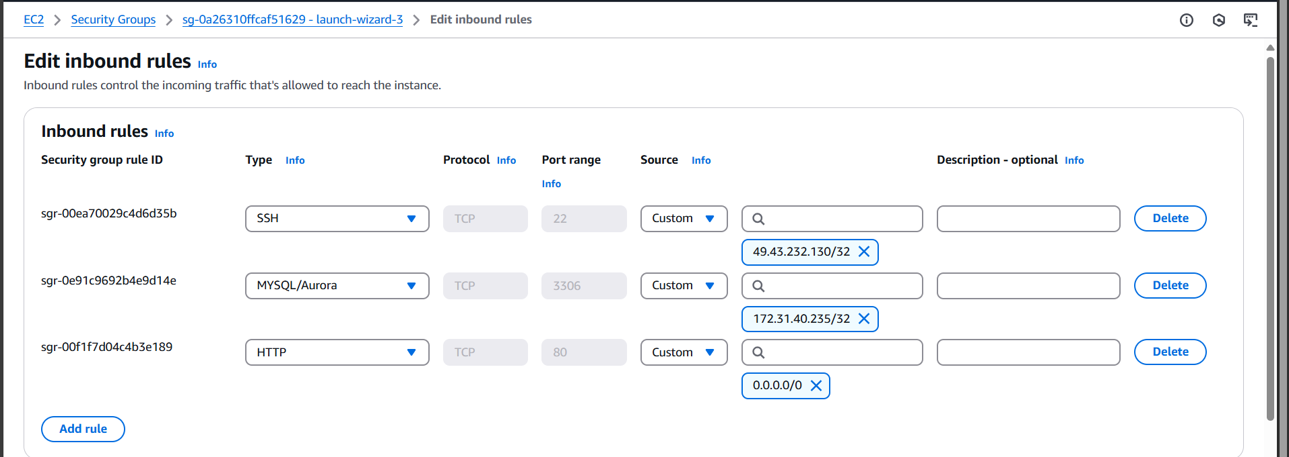

MySql SG

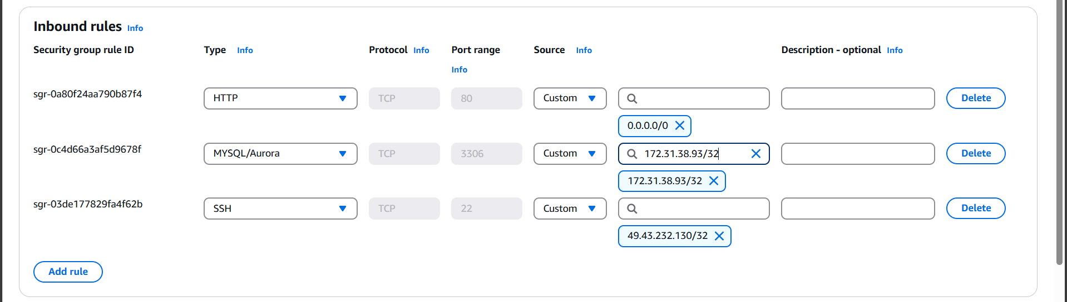

Setting Up MySQL Server (Database Instance)

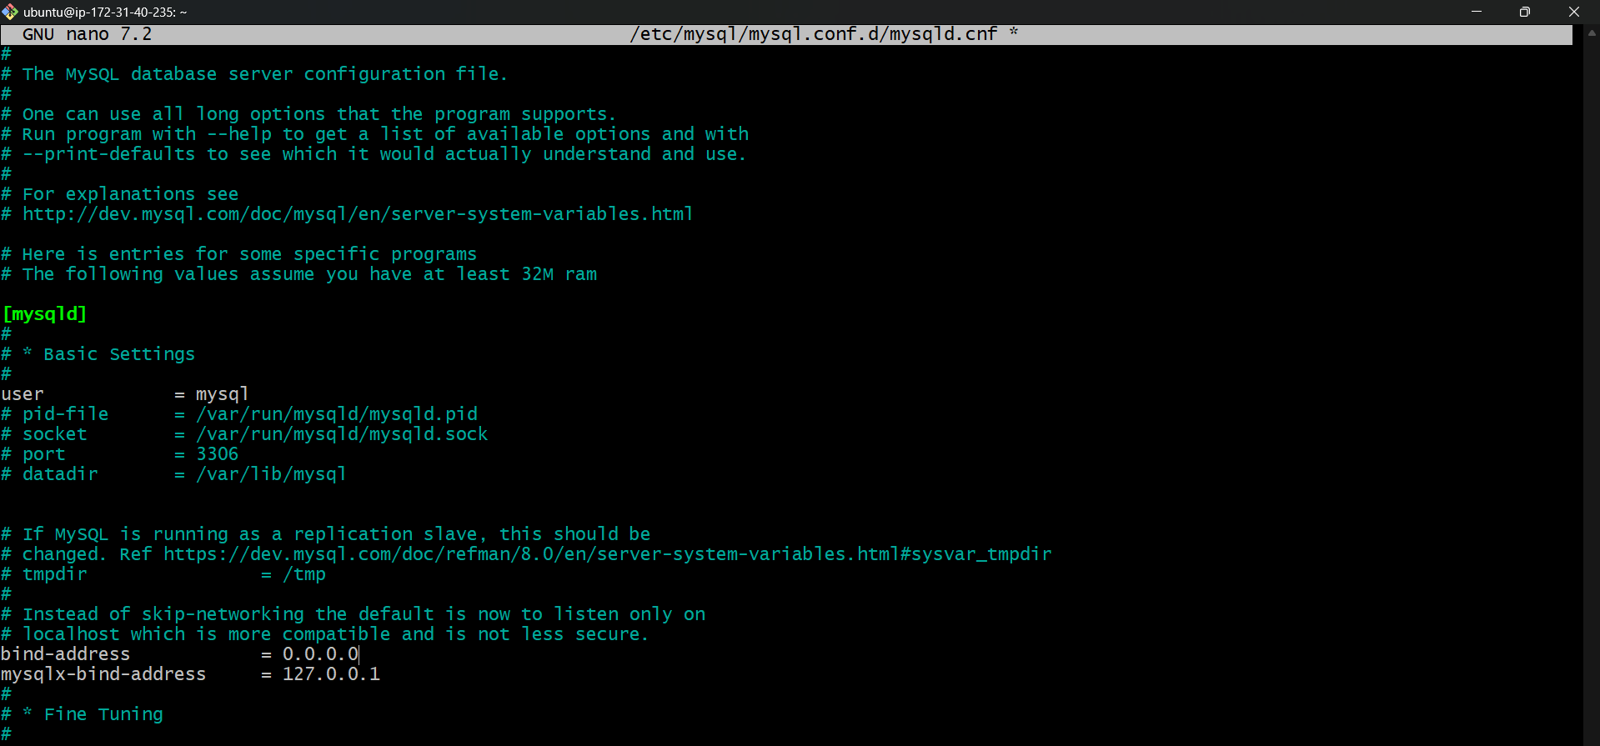

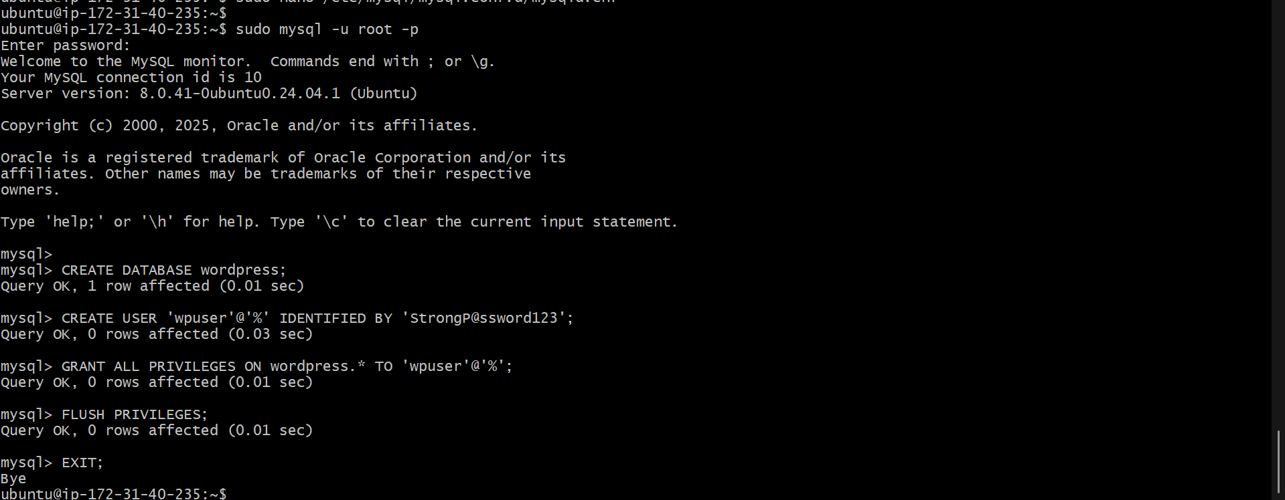  
  
History of commands of MySql Instance

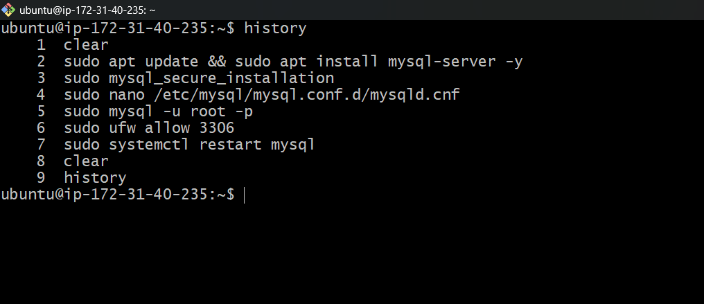

Setting Up the Application Server (WordPress Instance)

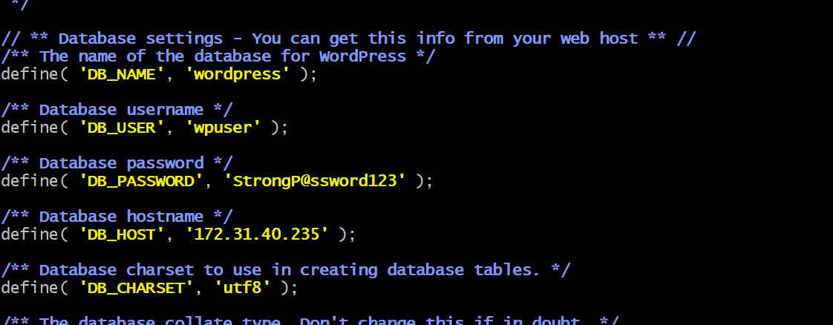

History of commands of WordPress Instance

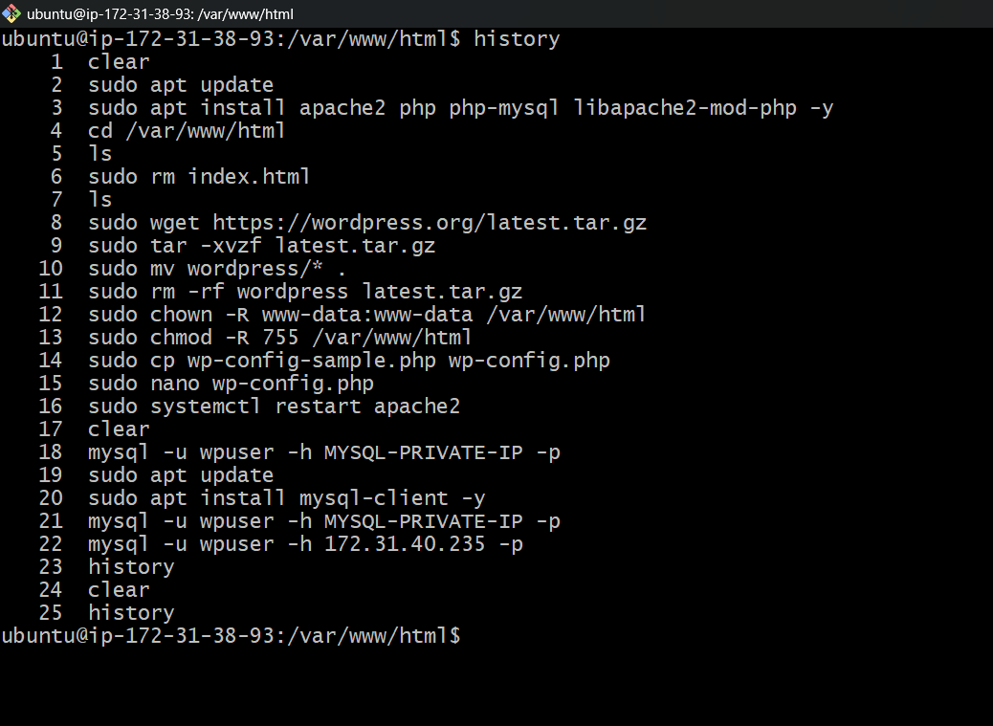

Accessed WordPress using **public IP/domain**.

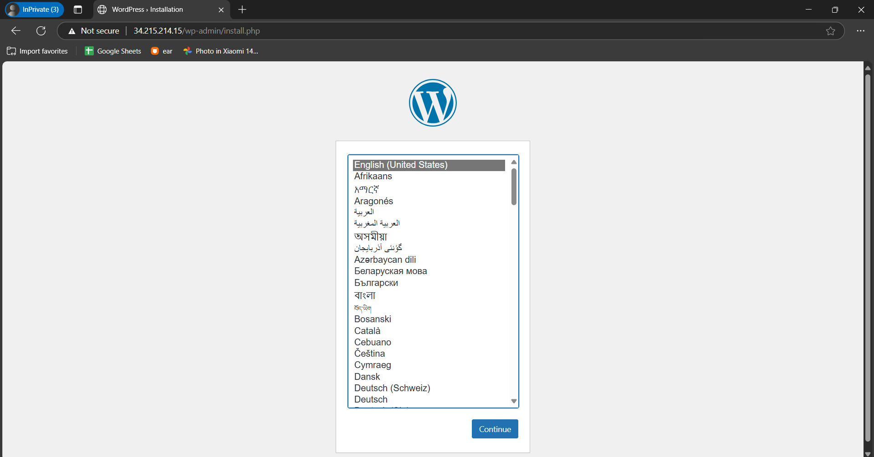

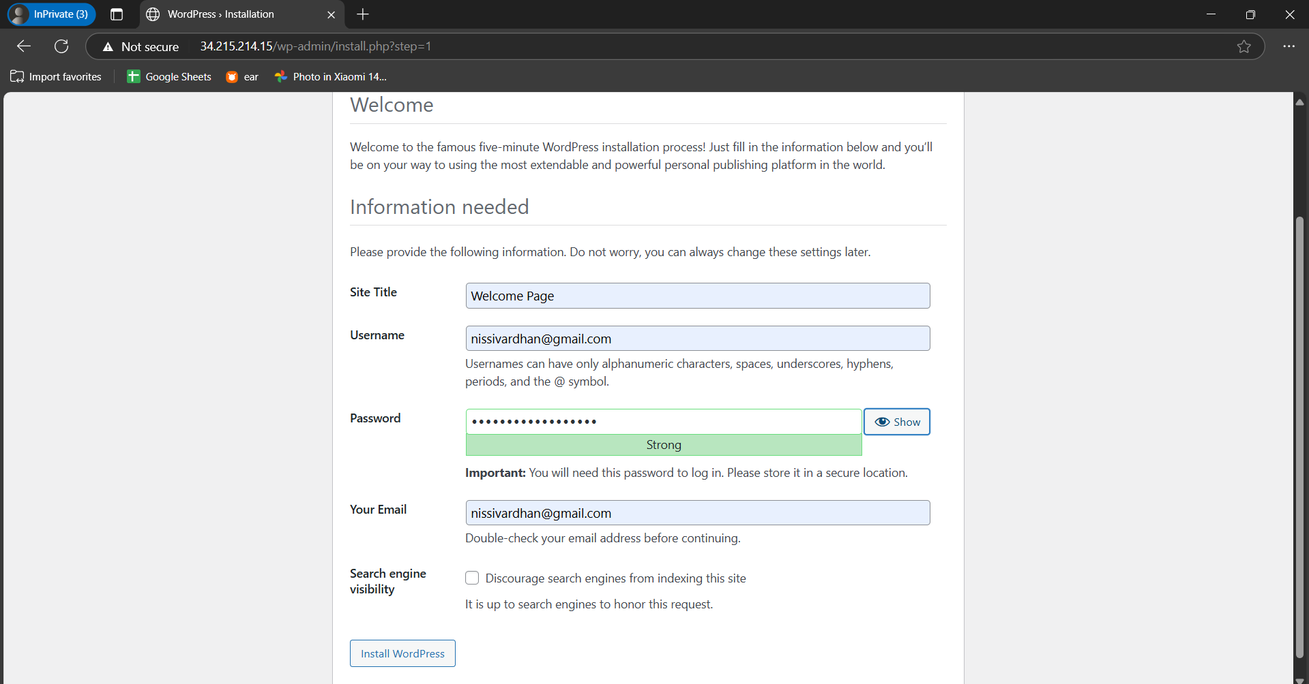

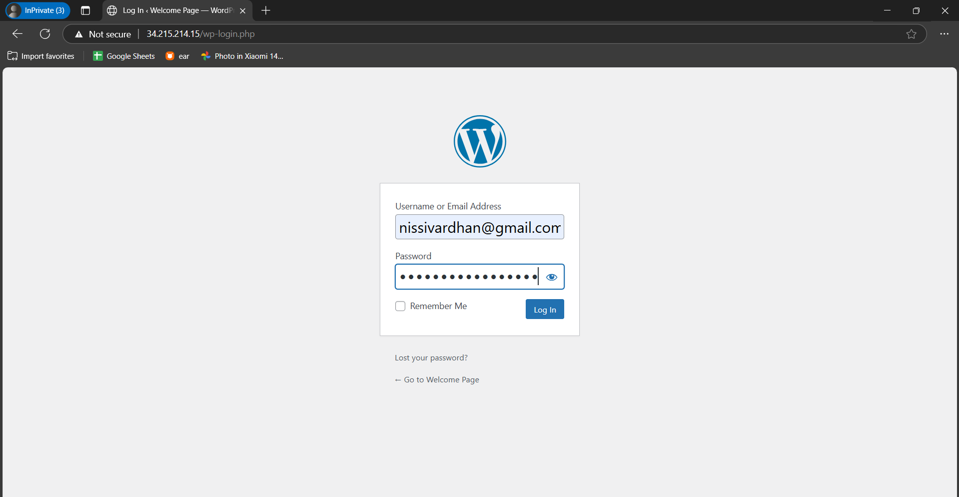

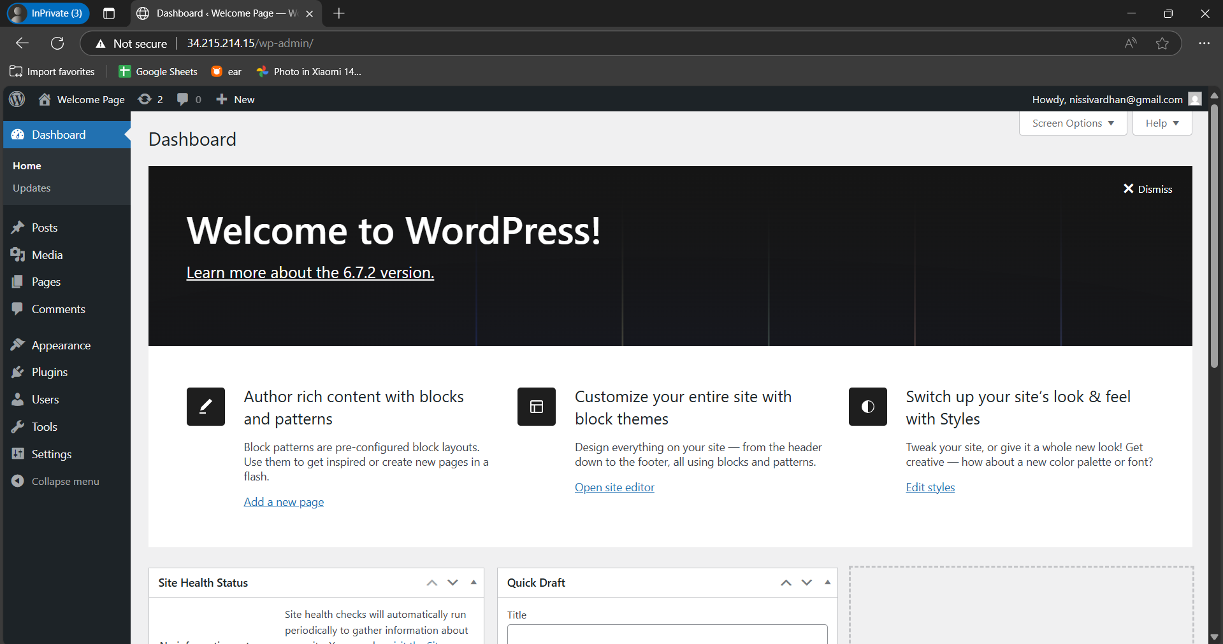

**References Used**

* AWS Documentation
* WordPress Setup Guide
* ChatGPT